**AGRIDRONE AUTOMATION OF**

**AGRICULTURE USING**

**IoT**

Submitted by

**PALLE MANJUNATH (U18EC135)**

**BOLLAPU HEMANTH KUMAR REDDY (U18EC129)**

**KARANAM VENKATA VEERA BRAHMAIAH (U18EC134)**

In partial fulfillment for the award of the degree of

**BACHELOR OF TECHNOLOGY**

**IN**

**ELECTRONICS & COMMUNICATION ENGINEERING**

PROJECT GUIDED BY

Dr M. SANGEETHA

**PROFESSOR**



**DEPARTMENT OF ELECTRONICS & COMMUNICATION ENGINEERING**

**BHARATH INSTITUTE OF HIGHER EDUCATION AND RESEARCH**

**DECEMBER 2021**

**BHARATH INSTITUTE OF HIGHER EDUCATION AND RESEARCH**

**BHARATH INSTITUTE OF SCIENCE AND TECHNOLOGY**

**CHENNAI – 600073, INDIA.**

**DEPARTMENT OF ELECTRONICS AND COMMUNICATION ENGINEERING**

**BONAFIDE CERTIFICATE**

This is to certify that this project entitled “**AGRIDRONE AUTOMATION OF AGRICULTURE USING IoT”** is the bonafide work of PALLE MANJUNATH(U18EC135), BOLLAPU HEMANTH KUMAR REDDY(U18EC129), KARANAM VENKATA VEERA BRAHMAIAH (U18EC134), who carried out the project work under our supervision. Certified further that to the best of my knowledge the work reported herein does not form part of any other thesis or dissertation on the basis of which a degree or award was conferred on an earlier occasion on this or any other candidate.

**SUPERVISOR HEAD OF THE DEPARTMENT**

**Dr. M. SANGEETHA Dr. H. UMMA HABIBA**

**Professor, Professor,**

Department of ECE Department of ECE

BIHER, BIHER,

Chennai - 600073 Chennai - 600073

Submitted for the Project Viva-Voce examination held on ……...…………….

**INTERNAL EXAMINER EXTERNAL EXAMINER**

**ACKNOWLEDGEMENT**

First of all, I express my sincere thankfulness to the almighty, for bestowing his blessings throughout this project work. I express my gratitude to my parents for their care, support, prayers and love.

My sincere thanks to our Honorable Chairman **Dr.S.Jagathrakshakan**, Honorable President, **Dr.J.Sundeep Aanand** and Managing Director **Dr.E.Swetha Sundeep Aanand,** Bharath Institute of Higher Education and Research, for their kind words and enthusiastic motivation which has inspired me a lot in completing my Project.

I would like to express my deep gratitude to our Vice Chancellor(I/C) **Dr. K.Vijaya Bhaskar Raju**, Pro Vice - Chancellor **Dr.R.M.Suresh,** Registrar **Dr.S.Bhuminathan,** Additional Registrar **Dr.R.Hariprakash,** Pro Vice Chancellor(Academics) **Dr.M.Sundararajan**, Pro Vice-Chancellor (Grants & Publications) **Dr. Suresh Kumar Subbiah**, Dean-Engineering **Dr. J.Hameed Hussain** who are responsible for moulding my thoughts in completing my Project. I am grateful to **Dr.M. Prem Jayakumar (Dean R & D**) for his valuable suggestions, kind co-operation and encouragement during the course of my study.

I wish to express my sincere profound gratitude to my esteemed and endowed Project guide Dr M.Sangeetha, for her inspiring guidance, healthy criticism, valuable suggestions and constant encouragement throughout the period of project.

I am thankful to the Head of the Department **Dr H. Umma Habiba**, Project co-coordinator M.Sangeetha, and all staff members of the Department of Electronics & Communication Engineering, BIHER, for their encouragement and guidance throughout the course of this project work.

I sincerely wish to express my thanks to the staff members of Library, BIHER for their valuable support during this project work. I would like to thank the authors of various journals and books whose works and results are used in the project.

**TABLE OF CONTENTS**

|  |  |  |  |
| --- | --- | --- | --- |
| **CHAPTER**  **NO** |  | **TITLE** | **PAGE**  **NO** |
|  |  | ABSTRACT | 1 |
|  |  | LIST OF FIGURES | 2 |
|  |  | LIST OF ABBREVIATIONS | 3 |
| 1 | 1.1 | INTRODUCTION | 4 |
|  | 1.2 | SCOPE OF THE PROJECT | 5 |
|  | 1.3 | RESEARCH OBJECTIVES | 6 |
|  | 1.4 | METHDOLOGY | 7 |
|  | 1.5 | CONTRIBUTIONS | 8 |
| 2 | 2.1 | LITERATURE SURVEY | 9 |
|  | 2.2 | APPLICATIONS | 11 |
| 3 |  | METHODS AND ALGORITHMS | 17 |
| 4 |  | EXISTING SYSTEM | 25 |
| 5 |  | PROPOSED SYSTEM | 30 |
| 6 |  | HARDWARE DESCRIPTION | 31 |
|  | 6.1 | RASPBERRY PI | 31 |
|  | 6.1.1 | FEATURES OF RASPBERRY PI 3 | 33 |
|  | 6.2 | TEMPERATURE AND HUMIDITY SENSOR | 34 |
|  | 6.3 | DRONE | 36 |
|  | 6.4 | MATERIALS FOR DRONE | 37 |
| 7 |  | HARDWARE IMPLEMENTATION | 38 |
| 8 |  | SOFTWARE DESCRIPTION | 45 |
|  | 8.1 | RASPIAN OS | 45 |
|  | 8.2 | PYTHON | 46 |
|  | 8.3 | IOT | 48 |
| 9 |  | SOFTWARE IMPLEMENTATION | 50 |
| 10 |  | OVERVIEW | 52 |
| 11 |  | RESULTS | 54 |
| 12 |  | CONCLUSION | 55 |
| 13 |  | FUTURE SCOPE | 56 |
| 14 |  | REFERENCES | 57 |

**ABSTRACT**

Agriculture is oldest profession of mankind. Very specifically, 80 percent of Indian population is engaged in agriculture related activities. No one can deny that farmers are losing their lives due to unmanageable debts increase due to failure of crops. Crop failures are due to various reasons. One of the main reason in crop failures is due to manual based, very traditional and un-scientific agriculture practices. In this work, an intelligent system is developed to watch the development of crops and various other very timely parameters of crops development.

The new system proposed here consists of a flying drone fitted with a camera eye to record images of crops in a scheduled time. The work involves developing an intelligent system by building a knowledge-base to guide agriculturists. The knowledge-base includes various cases of various crops and decisions based on crop image analysis. From captured images, the parameters that are planned for analysis by image processing are, the amount of green in leaf detection, moisture content in soil with supporting IoTs etc. The image of the plant will be acquired using the external camera eye fitted on drone which is interfaced with Raspberry Pi along with other different sensors modules through IOT. To detect green leaf we have to install Android studio in which PlantDoctorMaster-debug.apk file is created. Now we have to copy this apk file in the handset where TH classify application is installed.

**Index Terms** – Agridrone,remote-sensing,propellers,electric motors,transmitter & remote,battery,raspberry pi

**LIST OF FIGURES**

|  |  |  |  |
| --- | --- | --- | --- |
| **S.NO** | **FIGURE** | **TITLE** | **PAGE NO** |
| 1 | 3.1 | Block diagram of agriculture wonder drone system using micro-controller 8051 | 18 |
| 2 | 3.2 | Block diagram of agriculture wonder drone using GPS system | 19 |
| 3 | 3.3 | System block diagram using Atmega 328 | 20 |
| 4 | 3.4 | Atmega 644PA | 22 |
| 5 | 3.5 | BLCD motor | 24 |
| 6 | 3.6 | RF 2.4 GHz remote controller | 25 |
| 7 | 4.1 | Dry land detection | 27 |
| 8 | 4.2 | Wet land detection | 27 |
| 9 | 4.3 | Green leaf detection | 28 |
| 10 | 4.4 | Red soil detection | 28 |
| 11 | 4.5 | Brown soil detection | 29 |
| 12 | 4.6 | Leaf spot detection | 29 |
| 13 | 5.1 | Green leaf detection | 30 |
| 14 | 5.2 | Soil moisture detection | 31 |
| 15 | 6.1 | Raspberry pi | 32 |
| 16 | 6.2 | All parts | 37 |
| 17 | 7.1 | Parts for Assembling of a Drone | 38 |
| 18 | 7.2 | Sketch Design Of a Quadcopter | 41 |
| 19 | 7.3 | Designing of all parts | 42 |
| 20 | 7.4 | Axis Of a Drone | 42 |
| 21 | 7.5 | Take Off Motion | 43 |
| 22 | 7.6 | Landing Motion | 43 |
| 23 | 7.7 | Hardware implementation | 44 |
| 24 | 9.1 | Raspberry pi desktop | 51 |
| 25 | 10 | Overview images | 52 |
| 26 | 11 | Results images | 54 |

**LIST OF ABBREVIATIONS**

|  |  |  |
| --- | --- | --- |
| **S.NO** | **ABBREVIATION** | **EXPANSION** |
| 1 | UAV | Unmanned Aerial Vehical |
| 2 | GPS | Global Positioning System |
| 3 | FCB | Flight Controlled Board |
| 4 | WHO | World Health Organization |
| 5 | PCB | Printed Circute Board |
| 6 | WI-FI | Wireless Fidelity |
| 7 | ADC | Analog to Digital Converter |

**CHAPTER 1**

**1.1 INTRODUCTION**

Agriculture in India constitutes more than 60% of occupation. It serves to be the

backbone of Indian economy. It is very essential to improve the productivity

and efficiency of agriculture by providing safe cultivation of the farmer. The

various operations like spraying of pesticides and sprinkling fertilizer are very

important. Though spraying of pesticides has become mandatory it also proves

to be a harmful procedure for the farmers. Farmers especially when they spray

urea, take to many precautions like wearing appropriate outfit masks and

gloves. It will avoid any harmful effect on the farmers. Avoiding the pesticides

is also not completely possible as the required result has to be met. Hence fore,

use of robots in such cases gives the best of the solutions for this type of

problems, along with the required productivity and efficiency of the product .

According to survey conducted by WHO (world health organization) it is

estimated that every year about 3 million workers are affected by poisoning

from pesticides from which 18000 die. This projects aims to overcome the ill-

effect of the pesticides on human beings and also use to spray pesticides over

large area in short intervals of time compare to conventional spraying by

using automatic fertilizer sprayer. This device is basically combination of

spraying mechanism on a quad copter frame .

**1.2 SCOPE OF THE PROJECT**

Our drone has been designed to be a long range multicopter, which incorporates

easy landing and take-off characteristics without sacrificing range. This

especially suits it to farmland such as vineyards and orchards, where landing

area can be too limiting for a winged drone. No radio controlled flying

experience is required, the drone is launched by raising the throttle till it lifts

off, thereafter a single switch is flipped to activate autonomous mode. The

drone then flies its pre-planned mission, returns and lands itself.

The workflow for processing imagery has been simplified as far as possible,

with all required software included in the package. The user copies the captured

imagery from the cameras to the laptop and then follows a step-by-step

workflow to generate the final imagery. The workflow has been tested multiple

times, on a range of datasets and with deliberately poor data, and has proven to

be thoroughly robust. We guarantee excellent results.  Our end-to-end solution

does not require the user to upload imagery to a cloud service for external

processing – all processing is done on the included laptop. The user is able to

fly the drone in the morning and have high resolution photomaps and NDVI

imagery available later that day. AgriDrone designs, builds and sells fully

autonomous, self-contained drone systems to the agricultural and related

sectors. Our drone system includes everything you need to start flying

autonomously and mapping your farmland.

**1.3 RESEARCH OBJECTIVES**

The Drone is connected through wifi module to capture the images.Through raspberry pi we can able to send the obtained converted digital equivalent of the parameters over the internet and opencv allows this to process the drone. The Raspberry pi is connected to the Display through HDMI cable and the power supply is given to it. We use hard disk (SD card) for the storage. To detect the moisture in the soil we use NodeMcu which is connected to the power supply through Wifi module and moisture sensor is connected to the breadbroad which is used to check the moisture content in the soil and to check the dry land. The Raspberry Pi is a series of small single-board computers developed in the United Kingdom by the Raspberry Pi Foundation. Raspberry pi consists of 40 pins in which 8 pins are Ground pins and 4 pins are Power pins. Soil moisture sensors measure the volumetric water content in soil. Since the direct gravimetric measurement of free soil moisture requires removing, drying, and weighting of a sample, soil moisture . sensors measure the volumetric water content indirectly by using some other property of the soil, such as electrical resistance, dielectric constant, or interaction with neutrons, as a proxy for the moisture content. Unmanned aerial vehicle technology covers everything from the aerodynamics of the drone, materials in the manufacture of the physical UAV, to the circuit boards, chipset and software which are the brains of the drone. This UAV is ideal to explain drone technology because it has everything in one package. It includes the UAV, gimbal and camera and uses some of the top drone technology on the market today.

**1.4 METHDOLOGY**

Methodology of our system is approach to farming management is based on observing, measuring, and taking action based on real-time crop and livestock data. It erases the need for guesswork in modern farming and instead gives farmers the ability to maximize their yields and run more efficient organizations, all while enhancing crop production.

In recent years the cost of agriculture drones has rapidly declined, which has not only led to the explosion of drone use cases in agriculture but has made it a no-brainer investment for modern farmers.

In fact, the agricultural drone market is [expected to grow over 38%](https://www.marketwatch.com/press-release/agriculture-drones-market-global-industry-analysis-size-share-growth-trends-and-forecast-2018-2025-2018-09-10) in coming years. Driven by growing population levels and changing climate patterns, the need for efficient agriculture is only going to become more important.The sensors used are temperature and humidity sensor.

This project is very useful since we use High-tech drones allow farmers, and the drone pilots that operate them, to increase efficiency in certain aspects of the farming process. From crop monitoring to planting, livestock management, crop spraying, irrigation mapping, and more.

Below we dive deep into the agricultural drone market and its many applications, along with a look at the future of this exciting industry and what you can do to get started as an agricultural drone pilot.

**1.5 CONTRIBUTIONS**

The main results of this work is summarized at the last. The major contributions

of this work can be summarise as: The applicability of the Agriculture drone

has the potential to improve the crops. Agriculture Drone can helps the farmers

to transform the agriculture industry.

Now a day’s farmers use a hand pump for spraying pesticides. Human beings

take large amount of time to spray the crops and they don’t uniformly spray the

pesticides. But by using drone we can complete the spraying work in less

amount of time as compare to human.

Human being charges 500/- to 1000/- rupees per day for pesticides spraying, as

compared to them drone takes 3 watt of power then it will charge 50/- rupees

only of electricity. Drone will uniformly spray the fertilizers hence; there is no

possibility of damaging crops.

Drone will save the time of spraying pesticides and also it will reduces the

diseases caused by fertilizer to the human body such as skin diseases as per the

research of World Health Organization (WHO). Hence, drone will minimizes

the efforts of farmers for agriculture purpose. While deigning the required

circuitry it is very necessary to follow all the design and development steps for

PCB designing .

**CHAPTER 2**

**2.1 LITERATURE SURVEY**

* Deepak Murugan - “Development of an Adaptive Approach for Precision Agriculture Monitoring with Drone and Satellite Data”[2017] . Have proposed an approach for precision agriculture monitoring. It helps to distinguish between a sparse and a dense field using available data from the satellite and the drone. This approach works with image statistics of a region and helps to minimize drone activity.
* Paolo Tripicchio - “Towards Smart Farming and Sustainable Agriculture with Drones.”, International Conference onIntelligent Environments (IE), [2015]. Have stressed on the popularity of drones used in agriculture. With the help of an RGB-D sensor connected to the drone, various ploughing techniques can be distinguished. Two different algorithms are used to differentiate between the ploughing fields.
* Marthinus Reinecke - , “The influence of dronemonitoring on crop health and harvest size.”, 1st International Conference on Next Generation Computing Applications (NextComp), [2017]. Have proposed the usage of drones for the betterment of crop quality. This could help the farmers increase their production by detecting the loopholes beforehand. The crops could be managed by using specific cameras connected to the drones to detect water shortages and harmful pests.
* Floriano De Rango - “A simulator for UAVs management in agriculture domain.”, International Symposium on Performance Evaluation of Computer and Telecommunication Systems (SPECTS), [2017]. Have proposed the usage of a simulator that is suited to the agricultural fields. This simulator would coordinate with the UAV and control the activity of the UAV in the presence of harmful insects in the crops. It would also consider various other parameters like energy and the communication range of the drones.
* Rodrigo Filev Maia - “Precision agriculture using remote monitoring systems in Brazil.”, IEEE Global Humanitarian Technology Conference (GHTC), [2017]. Have discussed about an IoT device which is used to monitor various agricultural parameters. The device uses a network of sensors for measuring the soil temperature, humidity, moisture etc. The test was carried out in Sao Paulo, Brazil. Reference climate data was taken to support various decisions on crop life and its sustainability.

**2.2 HOW AGRICULTURAL DRONES ARE USED: 6 INNOVATIVE METHODS**

The use of drones in agriculture is here to stay.

Drone technology can help to accomplish once time-consuming and difficult tasks, all while reducing costs across the board.

You can expect the current uses of drones in agriculture to continue to evolve as the industry matures and new technology is introduced.

Currently, there are six common uses of agricultural drones, which we profile below:

### **1. Soil and Field Analysis**

At the beginning, middle, and end of a crop cycle drones can be used to help obtain useful data surrounding the quality of the existing soil. By obtaining 3D maps of existing soil, you’ll be able to see if there are any issues surrounding soil quality, nutrient management, or soil dead zones.

This information can help farmers determine the most effective patterns for planting, managing crops, soil, and more. Ongoing monitoring can help to better utilize water resources, and more effectively manage crop nutrient levels.

### **2. Seed Planting**

Drone planting is a relatively newer technology and not as widely used, but some companies are experimenting with drone planting. Essentially, manufacturers are experimenting with custom systems that have the ability to shoot seed pods into prepared soil.

Drone startup companies have been instrumental in developing unique drone technologies to assist with a wide range of ecological and agricultural issues. For example, the company [DroneSeed](https://uavcoach.com/droneseed/) is using unmanned aircraft capable of delivering up to 57 pounds of payload in the form of tree seeds, herbicides, fertilizer and water per aircraft per flight to assist reforestation and replanting projects.

This technology helps to minimize the need for on-the-ground planting, which can be costly, time-intensive, and strenuous work.

This same drone technology can be adapted and applied to a wide range of farm types, reducing overall planting times and labor costs across the board.

### **3. Crop Spraying and Spot Spraying**

Crops require consistent fertilization and spraying in order to maintain high yields. Traditionally this was done manually, with vehicles, or even via airplane. These methods are not only inefficient, and burdensome, but they can be very costly as well.

With [approval from the FAA](https://www.faa.gov/about/office_org/headquarters_offices/avs/offices/afx/afs/afs800/afs820/part137_oper/), Drones can be equipped with large reservoirs, which can be filled with fertilizers, herbicides, or pesticides. Using drones for crop spraying is much safer and cost-effective. Drones can even be operated completely autonomously and programmed to run on specific schedules and routes.

For example, if there’s a fungus breakout in a certain section of the crops, drones can be used to spot treat the issue. With the speed at which drones can operate, you can diagnose and treat potential crop issues before they become a widespread issue across the entire farm.

Spot spraying of crops used to be incredibly difficult. If you had an issue with weeds or a certain crop, the entire acreage would have to be sprayed.

This is a huge waste of time and resources, as someone will have to walk the entire acreage, plus there are the overall costs of pesticides and the associated environmental cost of chemical usage.

With spot spraying afforded by drones, this same task can be accomplished in less time, with fewer monetary resources, and a reduced environmental cost.

### **4. Crop Mapping and Surveying**

One of the biggest advantages of using drone technology is the ease and effectiveness of large-scale crop and acreage monitoring. In the past, satellite or plane imagery was used to help get a large scale view of the farm, while helping to spot potential issues.

However, these images were not only expensive but lacked the precision that drones can provide. Today, you can not only obtain real-time footage but also time-based animation which can illuminate crop progression in real-time.

With drone mapping and surveying, technology decisions can now be made based on real-time data, not outdated imagery, or best-practice guesswork.

With near infrared (NIR) drone sensors you can actually determine plant health based upon light absorption, giving you a birds-eye view of the overall farm health. We [recently interviewed](https://uavcoach.com/agricultural-drone-imagery/) a drone pilot who used NIR to help vineyard owners determine the health of their grapevines.

With agriculture drones you’ll be able to collect information like:

* The overall crop and plant health
* Land distribution based on crop type
* Current crop life cycle
* Detailed GPS maps of current crop area

The end result is simple, drones can help to maximize land and resource usage, and help farmers better determine crop planting locations.

### **5. Irrigation Monitoring and Management**

Irrigation can be troublesome. With miles and miles of irrigation, issues are bound to arise. Drones that are equipped with thermal cameras can help to spot irrigation issues, or areas that are receiving too little or excessive moisture.

With this information, crops can be better laid out to maximize drainage, adhere to natural land runoff, and avoid water pooling, which can damage sensitive crops.

Water and irrigation issues are not only costly but can ruin crop yields as well. With drone surveying, these issues can be spotted before they become troublesome.

### **6. Real-Time Livestock Monitoring**

Some drones are equipped with [thermal imaging cameras](https://uavcoach.com/thermal-camera-drone/) that enable a single pilot to manage and monitor livestock. This allows farmers to keep track of livestock a much greater frequency, and with less time and staff investment.

The drone operator can quickly check in on herd to see if there are any injured or missing livestock, as well as see livestock who are giving birth. Drones are used to keep an eye on the heard at all times, a once costly and time-intensive task.

Plus, thermal imaging will also help to keep an eye out for any livestock predators, which can be a huge advantage for some farm owners.

### **Launching Your Career as an Agriculture Drone Pilot**

Maximizing yields, minimizing costs, and future-proofing farms.

It’s easy to see why there’s so much excitement surrounding agriculture drones. Farms and agriculture businesses that embrace drones will quickly outcompete those who don’t.

As a result, agriculture drone pilots will become a pivotal asset to these companies.

Sounds like a thrilling and future-proof career to be in.

The field of agricultural drone work is still in its infancy. But, the biggest limiting factor in the growth of the field is the lack of trained pilots.

Luckily, if you’re reading this, you’re one click away from [becoming a certified drone pilot](https://uavcoach.com/drone-certification/). With the proper expert training and passion for the field, you can help to transform the way farming is done, and secure your place in a lucrative and rewarding industry.

As a professional agricultural drone pilot, you’ll be on the forefront of capturing farm, livestock, and land data, and quickly transforming this into actionable insights for farm production.

Once certified there are multiple methods for agriculture drone success including:

* Operating on a consultant basis offering land evaluation, and action-based farm improvement maps based on thermal and advanced imaging.
* Creating automated drone systems for existing farms to handle planting, spraying, and regular crop management.
* Contract work for regular crop monitoring, spraying, and detailed analyses to help maximize farm yields.
* Farm employment for big agricultural operators who need a dedicated agricultural drone pilot.
* Creating detailed maps for turf and other outdoor land management facilities.
* Executing in-depth studies about plant and crop survival and viability under different weather and climate conditions.

Expect the future of drone work, types of [drone contracts and jobs](https://uavcoach.com/uav-jobs/#guide-7), and business opportunities to continue to grow as adoption becomes more mainstream.

So, what does the future of agriculture drone technology hold?

By now, you can see there’s already a wide range of different drone applications currently in existence.

**CHAPTER 3**

**METHODS AND ALGORITHMS**

**Agriculture Wonder Drone System using micro-controller 8051**

The proposed system is an embedded system which will closely monitor and

control the microclimatic parameters of a greenhouse on a regular basis round

the clock for cultivation of crops or specific plant species which could

maximize their production over the whole crop growth season and to

eliminate the difficulties involved in the system by reducing human

intervention to the best possible extent. The system comprises of sensors,

Analog to Digital Converter, microcontroller and actuators. When any of the

above mentioned climatic parameters cross a safety threshold which has to be

maintained to protect the crops, the sensors sense the change and the

microcontroller reads this from the data at its input ports after being converted

to a digital form by the ADC. The microcontroller then performs the needed

actions by employing relays until the strayed-out parameter has been brought

back to its optimum level. Since a microcontroller is used as the heart of the

system, it makes the set-up low-cost and effective nevertheless. As the system

also employs an LCD display for continuously alerting the user about the

condition inside the greenhouse, the entire set-up becomes user friendly. Thus,

this system eliminates the drawbacks of the existing set-ups mentioned in the

previous section and is designed as an easy to maintain, flexible and low cost

solution . But unfortunately microcontroller has some drawbacks that can be

overcome with use of ARM processor . Limitations of ARM7 are Cost is high,

Complex instruction set, Complicated to designs because number of pin is

more.

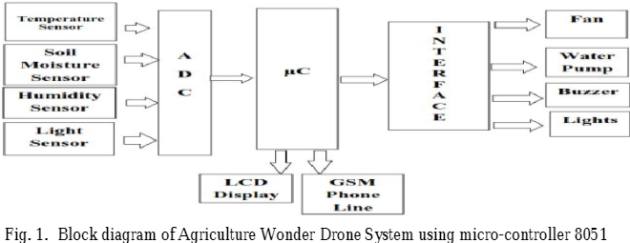3.1 Block diagram of agriculture wonder drone system using micro-controller 8051

**Agriculture Drone system using GPS**

The Agriculture Wonder Drone System is designed by making use of GPS

where the automatically controlled drone based on aerial pesticides sprayer

mainly consisting of two parts the quad copter and spraying mechanism.

Initially quad copter is assembled using necessary components such as flight

controlled board (FCB), GPS, BLDC motor, ESC controller and battery, etc.

Where the drone was behaved at required altitude, and then it is switch to

altitude hold mode, which maintains the same altitude until it is switched

back.

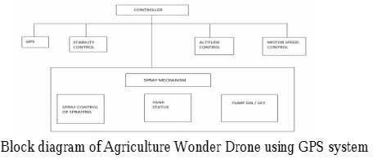 3.2 Block diagram of agriculture wonder drone using GPS system

The stability of drone maintain by sensors. GPS is used in only autonomous

mode. According to the changes in the values of sensors the motor speed is

vary. Pump used to turn ON/OFF the water pump which is used to spray. With

the help of GPS system can also share the data through wireless medium .

Agriculture wonder drone system using Atmega 328 All the limitation

discussed in above systems can be overcome if the system is implemented using

Atmega 328. This system is will used BLDC motors which are multiphase,

normally 3 phases, so direct supply of DC power will not turn the motor ON.

Electronic speed controller (4 used for the generating high frequency signals

with different but controllable phases to keep the motor turning.The ESC

controller is also able to source a lot of current as the motors can draw a lot of

power. 30 PRM 12V DC geared motors for robotic applications are very easy

to used and available in standard size. To measure acceleration

accelerometer used and to measured angular velocity gyro meter is used. LiPo

battery can be found in single cell of 3.7V to in a pack of over 10 cell connected

in a series (37V). Where the communication with the HMC5883L is simple and

all done are through an I2C interface. There is an on board regulator. The

breakout board includes the HMC5883L sensor and all filtering capacitors.

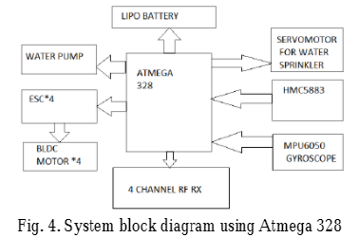

3.3 System block diagram using Atmega 328

**Agriculture Wonder Drone using ATMEGA 644PA**

The Agriculture Wonder Drone system is designed by making used of

Microcontroller Atmega 644PA. In this block diagram of Agriculture wonder

drone accelerometer and gyrometer sensors are used for the purpose of

measuring accelerations and force so the downward gravity will also be sensed.

A gyro meter is used for measuring angular velocity, in other words the

rotational speed around the three axes. There are different sections of

transmitter and receiver. In this block diagram the transmitter section consist of

signal sampling block which is used for quantization and sampling of signal.

Frequency modulator is used for modulation purpose and filtering part done

by band pass filter. The receiver section consisting of battery, ESC

controller, motors and sprinklers. Sprinkling has two sections simultaneously

remote controller and sprayer controller. The remote controller section is used

to control the actuator of sprinkler. The nozzle of sprayer module was get

activated by remote controller. Wherever there was a need to activate a sprayer

by RF transmitter remote. Sprayer model contains two modules spraying and

controller module. Pesticide was get spray and the controller section activated

the nozzle of the section. Tank status also gets verified.

**Atmega 644PA**

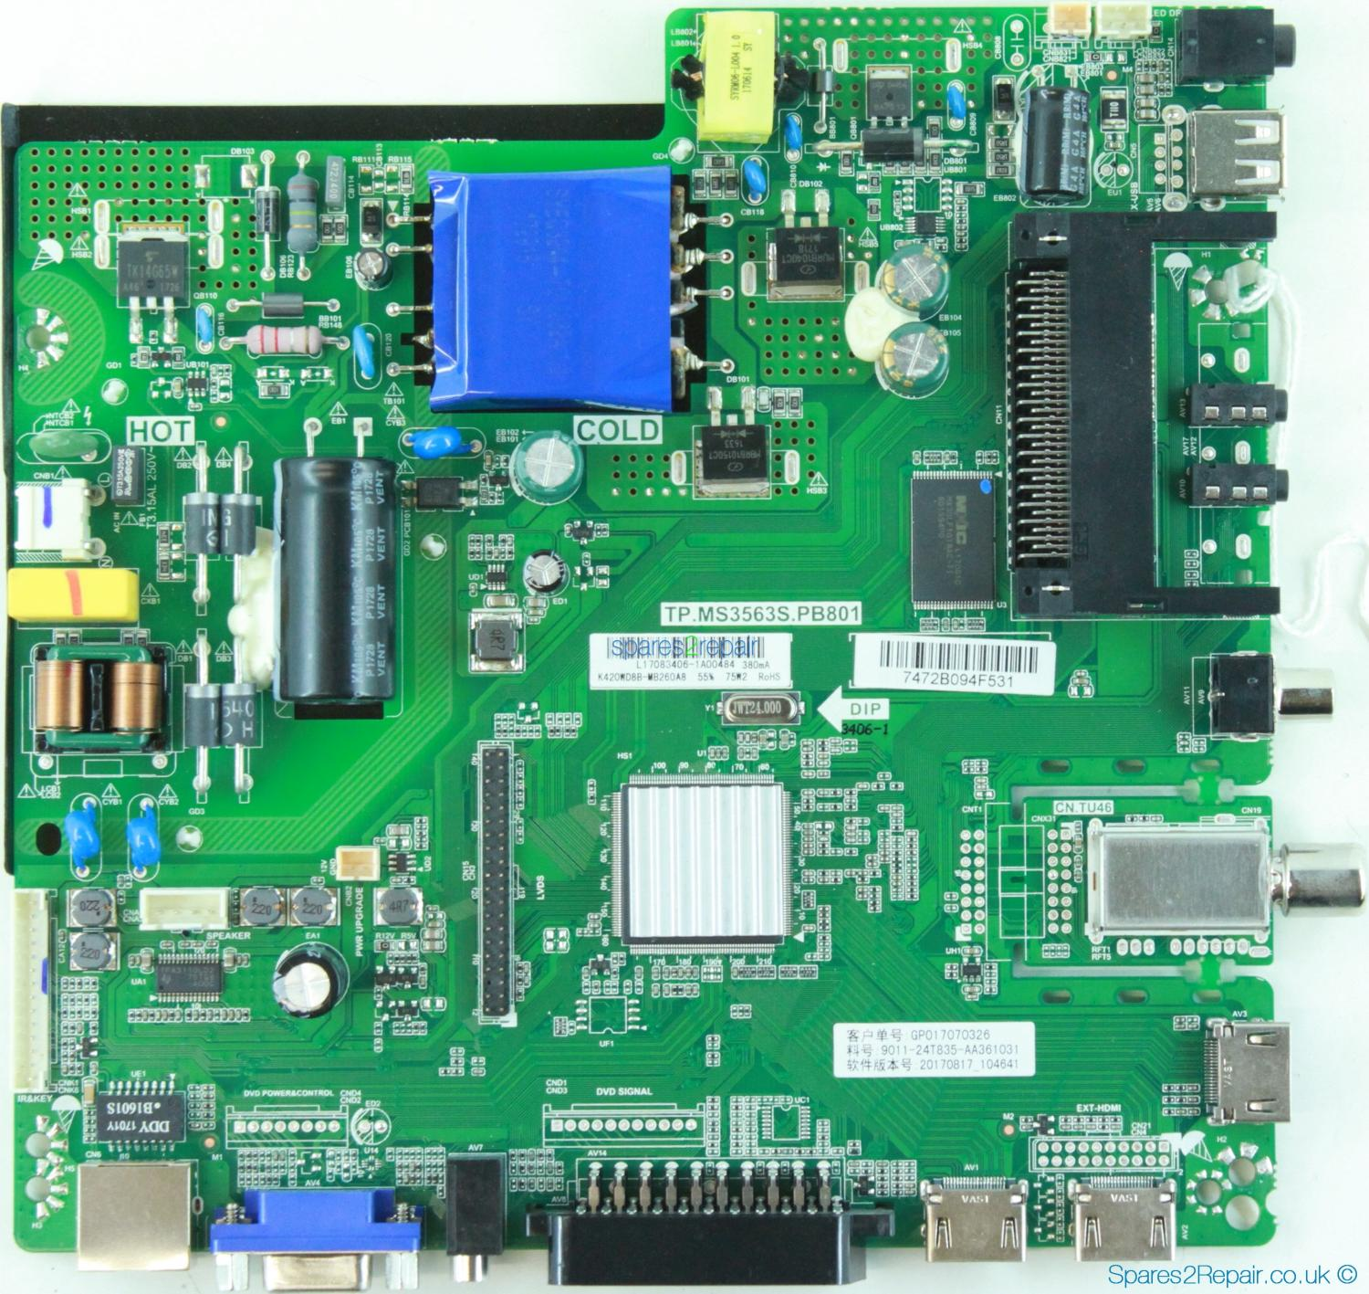

3.4 Atmega 644PA

It takes the signal from 6050 MPU Acc/gyro (roll pitch/yaw) then passes the

signal to Atmega 644PA IC. The Atmega 644PA IC unit processes this signal

according to user selected firmware and passes control signal to ESC. This

signal instructs to make fine adjustment to rotor rotational speed which in turn

stabilizes multi rotor craft. Hobby king 2.1.5 multi rotor control board which

uses the signal from radio system (RX) and passes the signal to the Atmega

644PA/IC via aileron, elevator, throttle and radar input. Once the information

has been proceed, The IC will send varying signal to ESC in which in turns

adjust the rotational speed of each rotor to induce controlled flight (up, down,

forward, reverse, left, right and yaw).

**LiPo battery**

Nominal voltage is the default, resting voltage of a battery pack. ... LiPo

batteries are fully charged when they reach 4.2v/cell, and their minimum safe

charge, as we will discuss in detail later, is 3.0v/cell. 3.7v is pretty much in

the middle, and that is the nominal charge of the cell.

**ESC controller**

An electronic speed control or ESC is an electronic circuit with is used to

control the speed of servo-motor, its direction and possibly also to act as a

dynamic brake. ESCs are often used on motors essentially providing an

electronically-generated three-phase electric power low voltage source of

energy for the motor. It also allows much smoother and more precise variation

of motor speed in a far more efficient manner than the mechanical type with a

resistive coil and moving arm once in common use.

**BLDC motors**

Brushless DC electric motor (BLDC motors, BL motors) also known as

electronically commutated motors (ECMs, EC motors), or synchronous DC

motors, are synchronous motors powered by DC electricity via an inverter or

switching power supply which produces an AC electric current to drive each

phase of the motor via a closed loop controller. The controller provides pulses

of current to the motor windings that control the speed and torque of the

motor. The construction of a brushless motor system is typically similar to a

permanent magnet synchronous motor (PMSM), but can also be a switched

reluctance motor, or an induction (asynchronous) motor.

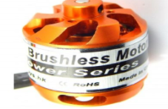

3.5 BLDC motor

**RF 2.4 GHz remote controller**

Many embedded devices use handheld IR and RF remote controls. TVs and

radios typically have Infrared (IR) remote controls. Most cars now have a radio

frequency (RF) remote key fob. Wireless keyboards and mice use RF links at

27 MHz or 2.4 GHz. Instead of IR one we one also use Node MCU. Less

complicated Wi-Fi module is inbuilt in node MCU.

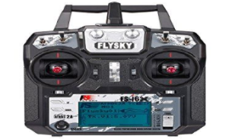

3.6 RF 2.4 GHz remote controller

**CHAPTER 4**

**EXISTING SYSTEM**

Considering connections, In this work, Drone is fitted with camera eye via Wi-

Fi module which is used to capture live images and Videos. To capture live

images and videos we have to install THWiFi FPV application in the mobile

phone and they are stored in the same application. To detect Moisture content

in the soil, the following connections are to be followed. Connect the two

pins of the moisture sensor to the two pins on the Amplifier circuit using jumper

wires. Connect the Vcc from the Amplifier to the 3.3V pin on the NodeMCU.

Connect the GND pin to the ground (GND) pin on the NodeMCU. Connect

the Analog pin to the A0 pin on the NodeMCU. Connect NodeMCU to PC via a

USB cable.

Now sign in to the “Thingspeak” now go to tools click board >

NodeMCU1.0>Port and choose the right port and now upload the code. Now

click on private view where the graph is displayed with time and date. If there

is no moisture content in soil then it is considered as Dry land and fixed value of

Dry land is 1024. To detect green leaf we have to install Android studio in

which PlantDoctorMaster-debug.apk file is created. Now we have to copy this

apk file in the handset where TH classify application is installed. In this

application select the photo captured by the Drone and the image is stored in the

Raspberry pi and now diagnose the result of the selected image and we will get

the confidence value.

**TEST CASES**

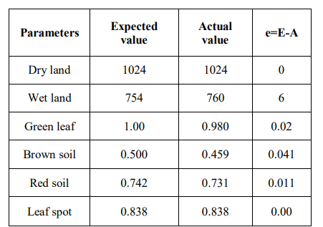

**TEST RESULTS**

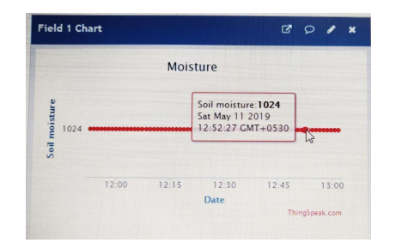

4.1 Dry Land Detection

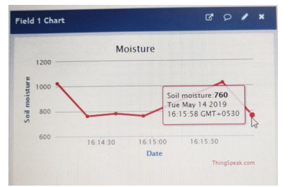

4.2 Wet Land Detection

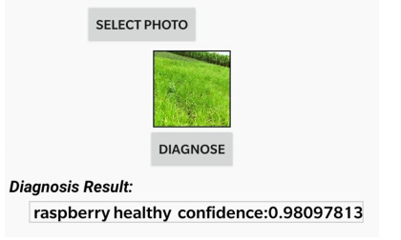

4.3 Green Leaf Detection

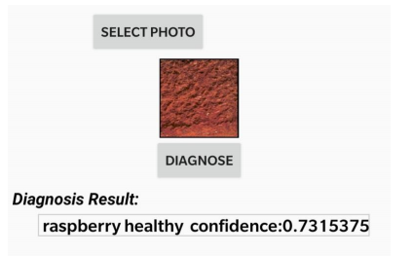

4.4 Red Soil Detection

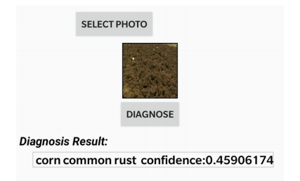

4.5 Brown Soil Detection

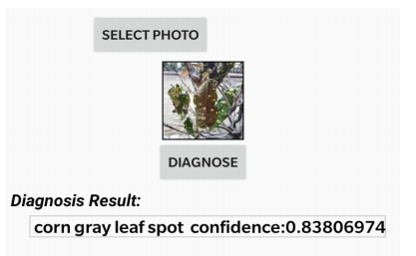

4.6 Leaf Spot Detection

**CHAPTER 5**

**PROPOSED SYSTEM**

The Drone is connected through wifi module to capture the images.Through raspberry pi we can able to send the obtained converted digital equivalent of the parameters over the internet and opencv allows this to process the drone. The Raspberry pi is connected to the Display through HDMI cable and the power supply is given to it. We use hard disk (SD card) for the storage.

To detect the moisture in the soil we use NodeMcu which is connected to the power supply through Wifi module and moisture sensor is connected to the breadbroad which is used to check the moisture content in the soil and to check the dry land.

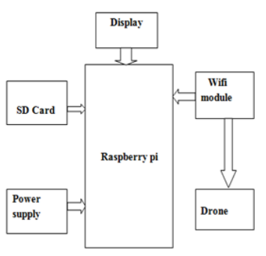

5.1 Green Leaf Detection

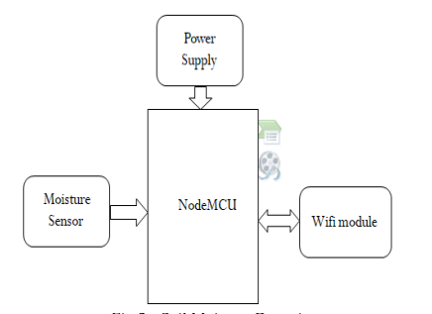

5.2 Soil Moisture Detection

**CHAPTER 6**

**HARDWARE DESCRIPTION**

**6.1 RASPBERRY PI**

Raspberry Pi is a Linux powered computer and definitely is a natural choice for IoT applications. The reason for raspberry pi being a preferred IoT device is because it runs a complete Linux Kernel and has direct interfaces such as Ethernet for wired internet as well as USB ports to connect to wifi. The operating system of raspberry Pi supports modern programming languages like python which makes IoT application development easier. Moreover, raspberry pi also has GPIOs so it can directly connect with devices, sensors and many real world devices. The Raspberry Pi is having a 40-Pin GPIO header, 4 x USB ports, 1x LAN port, 1x CSI and 1x Touch Screen interface, 1xhdmi port, 1xintegrated audio and video output port. The board runs on single +5v power supply for which there is a microUSB female connector provided.

The Raspberry-Pi is a credit card-sized single-board computer developed by the Raspberry Pi Foundation in UK to promote the teaching of basic computer science in schools and developing countries. Raspberry pi is controlled by a modified version of Debian Linux optimized for the ARM architecture. Here we are using raspberry pi 3. The setting up of pi consists of selecting Raspbian OS from prebuilt SD card. The prebuilt SD card consists of Raspbian, arc Linux, pidora, open ELEC, RISC OS operating system. After the OS selection we need to configure raspberry-pi using raspiconfig command. We can enter into raspberry pi desktop using startx command. The raspberry pi 3 is as shown in fig below.

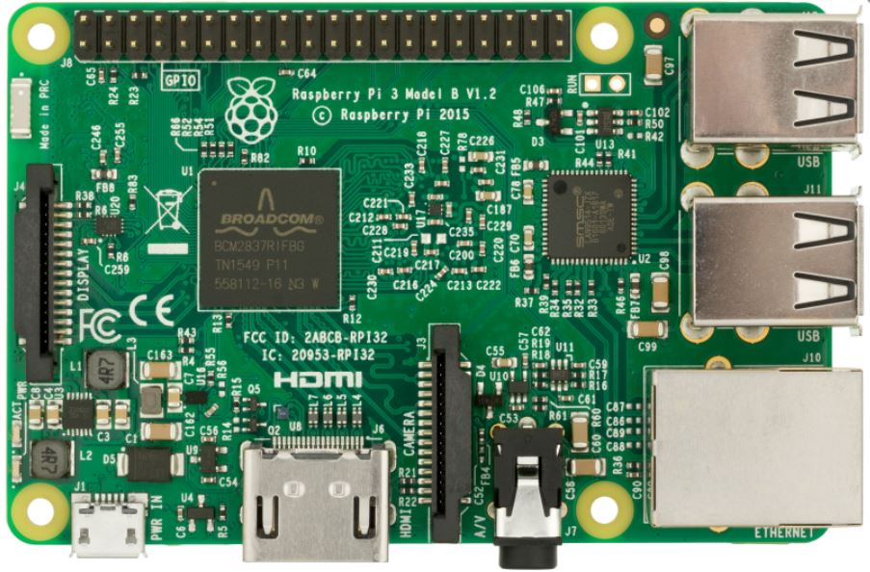

6.1 Raspberry Pi

The original Raspberry Pi and Raspberry Pi 3 are manufactured in several board configurations through licensed manufacturing agreements with Newark element14 (Premier Farnell), RS Components and Egoman. These companies sell the Raspberry Pisonline.Egoman produces a version for distribution solely in Taiwan, which can be distinguished from other Pis by their red colouring and lack of FCC/CE marks.

All models feature a Broadcom system on a chip (SoC), which includes an ARM compatible central processing unit (CPU) and an on chip graphics processing unit (GPU, a Video Core IV). CPU speed ranges from 700 MHz to 1.2 GHz for the Pi 3 and on board memory range from 256 MB to 1 GB RAM. Secure Digital SD cards are used to store the operating system and program memory in either the SDHC or Micro SDHC sizes. Most boards have between one and four USB slots, HDMI and composite video output, and a 3.5 mm phone jack for audio. Lower level output is provided by a number of GPIO pins which support common protocols like I²C. Some models have an 8P8C Ethernet port and the Pi 3 has on board Wi-Fi 802.11n and Bluetooth. The Foundation provides Debian and Arch Linux ARM distributions for download and promotes Python as the main programming language, with support for BBC BASIC (via the RISC OS image or the Brandy Basic clone for Linux), C,C++, PHP, Java, Perl, Ruby, Squeak Smalltalk, and more also available.

**6.1.1 FEATURES OF RASPBERRY PI 3:**

1. CPU: Quad-core 64-bit ARM Cortex A53 clocked at 1.2 GHz

2. GPU: 400MHz Video Core IV multimedia

3. Memory: 1GB LPDDR2-900 SDRAM (i.e. 900MHz)

4. USB ports: 4

5. Video outputs: HDMI, composite video (PAL and NTSC) via 3.5 mm jack

6. Network: 10/100Mbps Ethernet and 802.11n Wireless LAN

7. Peripherals: 17 GPIO plus specific functions, and HAT ID bus (Hardware Attached on Top)

8. Bluetooth: 4.1

9. Power source: 5 V via Micro USB or GPIO header

10. Size: 85.60mm × 56.5mm

11. Weight: 45g.

**6.2 TEMPERATURE AND HUMIDITY SENSOR**

Temperature is the most often-measured environmental quantity. This might be expected since most physical, electronic, chemical, mechanical, and biological systems are affected by temperature. Certain chemical reactions, biological processes, and even electronic circuits perform best within limited temperature ranges. Temperature is one of the most commonly measured variables and it is therefore not surprising that there are many ways of sensing it. Temperature sensing can be done either through direct contact with the heating source, or remotely, without direct contact with the source using radiated energy instead. There are a wide variety of temperature sensors on the market today, including Thermocouples, Resistance Temperature Detectors (RTDs), Thermistors, Infrared, and Semiconductor Sensors.

There are a wide variety of temperature sensor ICs that are available to simplify the broadest possible range of temperature monitoring challenges. These silicon temperature sensors differ significantly from the above mentioned types in a couple of important ways. The first is operating temperature range. A temperature sensor IC can operate over the nominal IC temperature range of -55°C to +150°C. The second major difference is functionality.

A silicon temperature sensor is an integrated circuit, and can therefore include extensive signal processing circuitry within the same package as the sensor. There is no need to add compensation circuits for temperature sensor Ics. Some of these are analogue circuits with either voltage or current output. Others combine analogue-sensing circuits with voltage comparators to provide alert functions. Some other sensor ICs combine analogue-sensing circuitry with digital input/output and control registers, making them an ideal solution for microprocessor-based systems.

Digital output sensor usually contains a temperature sensor, analog-to-digital converter (ADC), a two-wire digital interface and registers for controlling the IC’s operation. Temperature is continuously measured and can be read at any time. If desired, the host processor can instruct the sensor to monitor temperature and take an output pin high (or low) if temperature exceeds a programmed limit. Lower threshold temperature can also be programmed and the host can be notified when temperature has dropped below this threshold. Thus, digital output sensor can be used for reliable temperature monitoring in microprocessor-based systems.

Temperature sensors directly connected to microprocessor input and thus capable of direct and reliable communication with microprocessors. The sensor unit can communicate effectively with low-cost processors without the need of A/D converters.

**6.3 DRONE**

A Drone or Quadcopter is a Vehicles have large potential for performing tasks that are dangerous or very costly for humans. Examples are the inspection of high structures, humanitarian purposes or search-and-rescue missions. One specific type of Drone is becoming increasingly more popular lately: the quadcopter . When visiting large events or parties, professional quadcopters can be seen that are used to capture video for promotional or surveillance purposes. Recreational use is increasing as well: for less than 50 Euros a small remote controlled quadcopter can be bought to fly around in your living room or garden. In these situations the quadcopter is usually in free flight. There is no physical contact between the surroundings and the quad copter and no cooperation between the quadcopters If would have the capabilities to collaborate the number of possibilities grows even further. For example, a group of Drone would be able to efficiently and autonomously search a missing person in a large area by sharing data between. Or, the combined load capacity of a group of quad copters can be used to deliver medicine in remote areas. This bachelor thesis focuses on the use of a commercially available quadcopter platform, the.Drone, to perform a task that requires physical collaboration and interaction: moving a mass. In this way a clear interaction between the quadcopters and their surroundings is present. As preliminary step towards the view of collaborating aerial robots the choice was made to perform this task in an indoor scenario where position feedback is present. Starting off with position control, additional controller logic can be implemented to counteract the forces imposed by a mass connected to the quadcopter. The choice is made for the Drone, a generalized approach is chosen where possible to encourage reuse of this research’s outcome and deliverables. (1) A helicopter is a flying vehicle which uses rapidly spinning rotors to push air downwards, thus creating a thrust force keeping the helicopter aloft. Conventional helicopters have two rotors. These can be arranged as two coplanar rotors both providing upwards thrust, but spinning in opposite directions (in order to balance the torques exerted upon the body of the helicopter).

**6.4 MATERIALS FOR DRONE**

For someone new to the multirotor hobby, putting together our first quadcopter parts list can be extremely daunting. Trying to figure out what to buy and what parts will work together is tough, especially for people who don’t come from a background in radio controlled planes or helicopters. Forums are packed with people who want to build a quadcopter but don’t know where to start. It can be frustrating trying to sort through the thousands of posts on forums and blogs and figure out what to do.

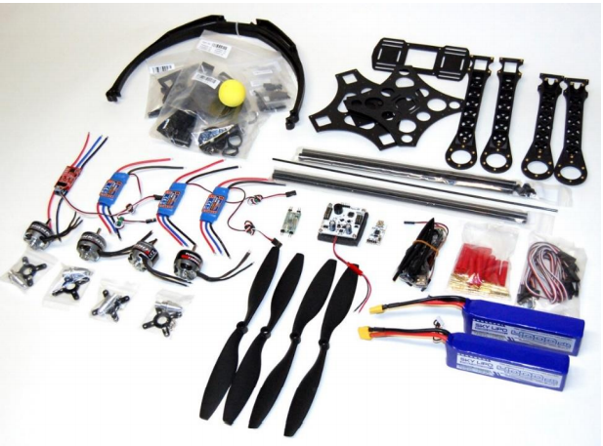

6.2 All parts

**CHAPTER 7**

**HARDWARE IMPLEMENTATION**

We’ve heard from a lot of readers who are in similar positions and this post is

designed to spell out exactly what you need for your first quadcopter build.

While we will recommend a complete list of specific parts that we have used

and tested for a complete quadcopter build, the main purpose of this post is to

provide a general overview of the parts needed to build a quadcopter. Here’s

what you’ll need:

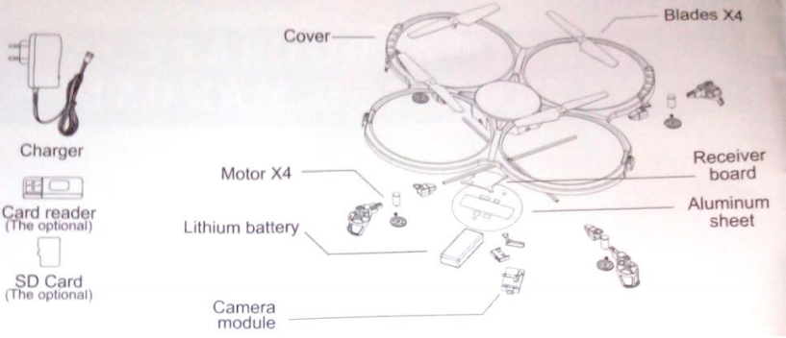

7.1 Parts for Assembling of a Drone

**SPECIFICATIONS**

**ELECTRONIC ASSISTANCE**

Extreme precision control and automatic stabilization features.

* 1GHz 32 bit ARM Cortex A8 processor with 800MHz video DSP TMS320DMC64x
* Linux 2.6.32
* 1Gbit DDR2 RAM at 200MHz
* 3 axis gyroscope 2000°/second precision
* 3 axis accelerometer +-50mg precision
* 3 axis magnetometer 6° precision
* Pressure sensor +/- 10 Pa precision
* Ultrasound sensors for ground altitude measurement
* 60 fps vertical QVGA camera for ground speed measurement

**MOTORS**

Fly high. Fly fast. Far away from the ground.

* 4 brushless inrunner motors. 14.5W 28,500 RMP
* Micro ball bearing
* Low noise Nylatron gears for 1/8.75 propeller reductor
* Tempered steel propeller shaft
* Self-lubrificating bronze bearing
* Specific high propelled drag for great maneuverability
* 8 MIPS AVR CPU per motor controller
* 3 elements 1000 mA/H LiPo rechargeable battery (Autonomy: 12 minutes)
* Emergency stop controlled by software
* Fully reprogrammable motor controller

**Technical Specification**

3 cell 1,000 mAH LiPo rechargeable battery; High pitch propeller for great manoeuvrability; 4 brushless inrunner motors with micro ball bearing and rare earth magnets, 14.5 watt & 28,500 rpm when hovering; Self-lubricating bronze bearings, tempered steel prop shafts; Low noise Nylatron gears for 8.625 propeller shafts; Emergency stop controlled by software; Fully reprogrammable motor controller; Water resistant electronic motor controller ; Foam to isolate the inertial center from the engine’s vibrations; EPP hull; Carbon fibre tubes, 380g with outdoor hull, 420g with indoor hull; High grade 30% fibre charged nylon plastic parts;

**Methodology Adopted for Assembling of a Drone.**

**Working Principle**

First , we are making a frame of light weight material. 2. Quadcopter is a device with a intense mixture of Electronics, Mechanical and mainly on the principle of Aviation. 3. The Quadcopter has 4 motors whose speed of rotation and the direction of rotation changes according to the users desire to move the device in a particular direction (i.e Takeoff motion, Landing motion, Forward motion, Backward motion, Left motion, Right Motion.) 4. The rotation of Motors changes as per the transmitted signal send from the 6-Channel transmitter. 5. The signal from microcontroller goes to ESC’s which in turn control the speed of motor.

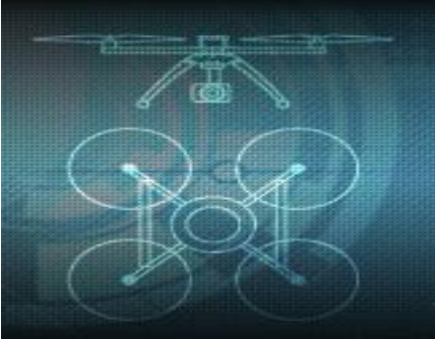

7.2 Sketch Design Of a Quadcopter

This chapter introduces some of the main concepts and background knowledge related to this project. A generic model of a quadcopter (Fig. 3.3) will be introduced, as well as methods of connecting masses to UAVs and an introduction to controller actions.

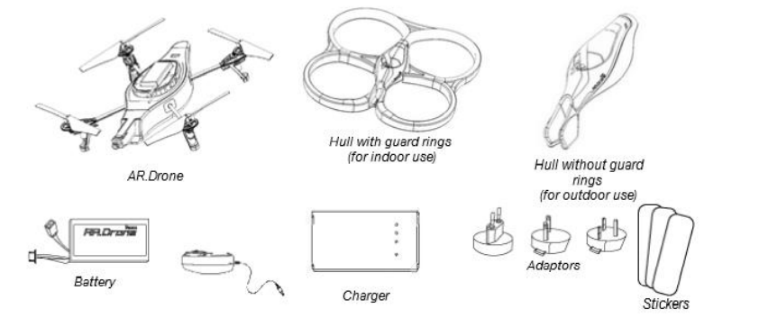

7.3 Designing of all parts

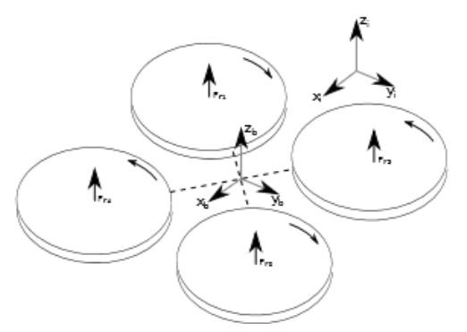

7.4 Axis Of a Drone

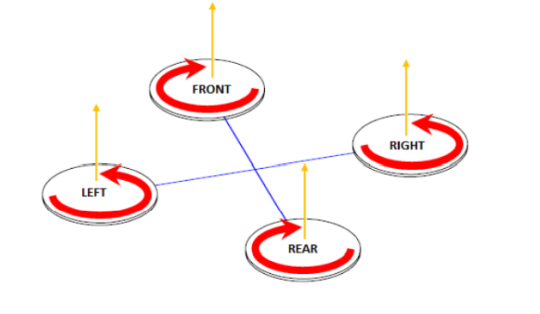

7.5 Take Off Motion

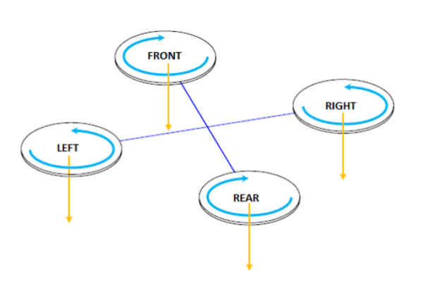

7.6 Landing Motion

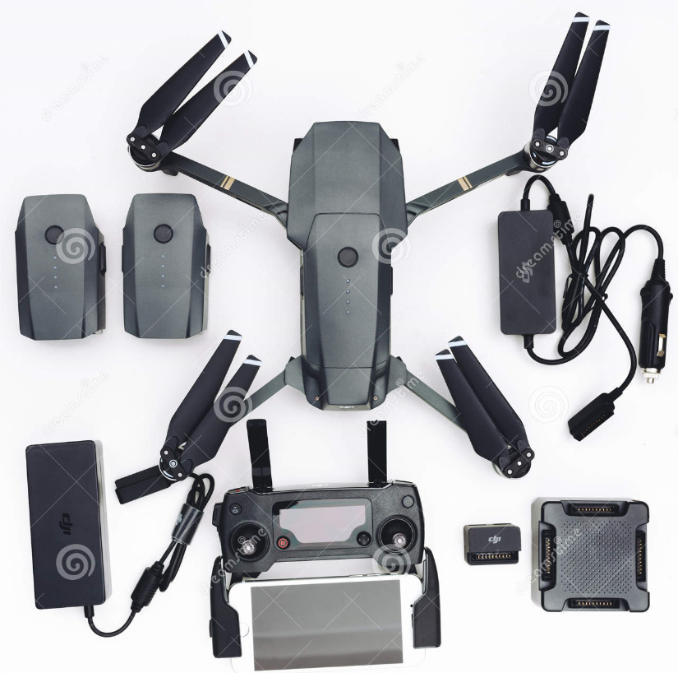

7.7 Hardware Implementation

**CHAPTER 8**

**SOFTWARE DESCRIPTION**

**8.1 RASPIAN OS**

Raspbian is a Debian-based computer operating system for Raspberry Pi. There are several versions of Raspbian including Raspbian Stretch and Raspbian Jessie. Since 2015 it has been officially provided by the Raspberry Pi Foundation as the primary operating system for the family of Raspberry Pi single-board computers.Raspbian was created by Mike Thompson and Peter Green as an independent project.The initial build was completed in June 2012.The operating system is still under active development. Raspbian is highly optimized for the Raspberry Pi line's low-performance ARM CPUs.

Raspbian uses PIXEL, Pi Improved Xwindows Environment, Lightweight as its main desktop environment as of the latest update. It is composed of a modified LXDE desktop environment and the Openbox stacking window manager with a new theme and few other changes. The distribution is shipped with a copy of computer algebra program Mathematica and a version of Minecraft called MinecraftPi as well as a lightweight version of Chromium as of the latest version.

You need a preloaded SD card, USB keyboard, TV/Monitor (with HDMI/ DVI/ Composite/SCART input), and power supply (USB charger or a USB port from a powered USB Hub or another computer). You will likely also want a USB mouse, a case, and a USB hub (a necessity for Model A). A powered USB hub will reduce the demand on the RPi. To connect to the Internet, you'll need either an Ethernet/LAN cable (Model B) or a USB WiFi adaptor (either model). When setting up, it is advisable to connect the power after everything else is ready.

The raspberry pi’s raspbian operating system is preloaded with the GCC compiler suite. This GCC compiler is not needed to be installed separately and hence raspberry pi directly run C programs without installing anything extra. But the embedded coding requires access to the Raspberry Pi GPIO’s and for that sake; it’s a must to install additional libraries. In the short time that the Raspberry Pi has been around, a considerable number of programming languages have been adapted for the Raspberry Pi, either by the creator of the language, who wanted to support the Pi by porting their creation or by enthusiastic users who wanted to see their language of choice available on their platform of choice. The Raspberry Pi Foundation recommends Python as a language for learners. Any language which will compile for ARMv6 can be used with the Raspberry Pi, though; so you are not limited to using Python. C, C++, Java, Scratch, and Ruby all come installed by default on the Raspberry Pi.

**8.2 PYTHON**

Python is an interpreted high-level programming language for general-purpose programming. Created by Guido van Rossum and first released in 1991, Python has a design philosophy that emphasizes code readability, and a syntax that allows programmers to express concepts in fewer lines of code, notably using significant whitespace. It provides constructs that enable clear programming on both small and large scales.

Python features a dynamic type system and automatic memory management. It supports multiple programming paradigms, including object-oriented, imperative, functional and procedural, and has a large and comprehensive standard library.

Python interpreters are available for many operating systems. CPython, the reference implementation of Python, is open source software and has a community-based development model, as do nearly all of its variant implementations. CPython is managed by the non-profit Python Software Foundation.

Python is considered to be the simplest of all programming languages by many. This is the reason why many people prefer using python on the raspberry pi. As python was being preferred by the raspberry pi foundation itself, later on, it happened so that many people who wanted to write device drivers, firmware and sample codes for various GPIO interfaces to raspberry pi, began naturally to write all these things in python only. This leads to a wave of programming stuffs and material being done in python. The gitbuh.com contains loads of different user contributed libraries to make working on raspberry pi using python a delight. Python is a much high-level, interpreted, interactive and object-oriented programming and scripting language. Python is designed to be highly readable. It uses English keywords frequently where as other languages use punctuation. Python was developed by Guido van Rossum in the late eighties and early nineties at the National Research Institute for Mathematics and Computer Science in the Netherlands.

Python is a multi-paradigm programming language. Object-oriented programming and structured programming are fully supported, and many of its features support functional programming and aspect-oriented programming (including by metaprogramming and metaobjects (magic methods)). Many other paradigms are supported via extensions, including design by contract and logic programming.

Python uses dynamic typing, and a combination of reference counting and a cycle-detecting garbage collector for memory management. It also features dynamic name resolution (late binding), which binds method and variable names during program execution.

Python's design offers some support for functional programming in the Lisp tradition. It has filter, map, and reduce functions; list comprehensions, dictionaries, and sets; and generator expressions. The standard library has two modules (itertools and functools) that implement functional tools borrowed from Haskell and Standard ML.

**8.3 IOT**

The term „Internet of Things‟ consists of two words, namely Internet and Things. Internet refers to the global network infrastructure with scalable, configurable capabilities based on interoperable and standard communication protocols. Things are physical objects or devices, or virtual objects, devices or information, which have identities, physical attributes and virtual personalities, and use intelligent interfaces . For instance, a virtual object can represent an abstract unit of sensor nodes that contains metadata to identify and discover its corresponding sensor nodes. Therefore, IoT refers to the things that can provide information from the physical environment through the Internet.

The Internet of things is becoming an increasingly growing topic of conversation both in workplace and outside of it. Broadband internet connection has become more widely available almost everywhere in the world. The costs involved in broadband internet connection are reducing almost every day and hence the cost of connecting to the internet has drastically being reduced. Additionally more devices are being connected using Wi-Fi technology removing the wired complexity and costs involved giving wireless freedom for internet connectivity. So hence, more and more devices are being built everyday with capability to connect to the internet, share and send some data to internet and receive any data coming from internet. Thus, IoT is a concept of basically connecting any device with an On and Off switch to the internet. This device can be anything from cell phone, coffee vending machine, water geyser, microwave oven, lamps, room lights and anything we can think of. It’s going to be beyond the connected computers term which is in use for so long term. IoT is going to be a giant network where every device imaginable would be connected to internet. Now the benefit of this IoT term is beyond simple discussion. There are numerous applications from household appliance control to industrial process controls.

Embedded Devices connected to internet can accept On Off commands from internet; share all the data available with them to the internet. The user of system can be sitting anywhere in the world and control his home appliances or industrial processes by just looking on his computer screen where he can open a web browser and put address of his device. The embedded device may serve an HTML page of its own just like a web site page loads where user can see any data related to the device. Similarly there are large numbers of applications where data analysis can be done in a much smarter way. In many cases, the embedded device connected to internet does not serve HTML page, but simply send the parameters that are sensed using HTTP requests to the server and it’s up to the server side programming to analyse data properly and arrange in a way where user can effectively read and observer the data. Internet of Things, is in use already and there are many implementations of it. To implement IoT on embedded system, the system needs to have a programmable element and internet connection through either Ethernet interface or through Wi-Fi Interface and send data to a web based service. Nowadays there are many Cloud Service providers for IoT application where user can subscribe to a cloud service, take some user name, password and API key from them and send data to his own cloud space. This way eliminates the user from the complex programming and networking related to the server side and focus on embedded applications. There are many such examples of available cloud services e.g. [www.kaaproject](http://www.kaaproject).org, dataplicity.com, [www.nearbus](http://www.nearbus).net, [www.teleduino](http://www.teleduino).org. Most of these cloud service providers also provide their own mobile OS app also where user can see his data on mobile app and can also control some devices directly through mobile App. The devices used for embedded platform building can be any small microcontrollers. If smart devices with sufficiently more computing power are used, the IoT applications run smoother. There are many Linux powered boards available today which makes developing IoT applications very easy.

**CHAPTER 9**

**SOFTWARE IMPLEMENTATION**

The software implementation starts with the selection of OS for Raspberry pi board. For our purpose we are selecting the Raspbian OS. The configuration settings of the Raspberry pi are made as per the user requirement using raspi-config command. For programming we choose Python language. Python is an easy programming language for users to interface numerous sensors with Raspberry pi. The Raspberry pi desktop and configuration settings are as shown below.



9.1 Raspberry Pi desktop

The output from the Temperature, Humidity is monitored and speed of the motor is controlled by dumping the code into Raspberry Pi.The simulation is done using python language.

Software Coding is done in such a way that the Temperature , Humidity , Vibration and Gas level from one end and received at the other end and it ensures the Temperature between 0-36˚C, Humidity beween 0-60 g/m3 are to be normal and if any of these parameters exceeds or lags behind the mentioned value it sends an alert message.

**CHAPTER 10**

**OVERVIEW**

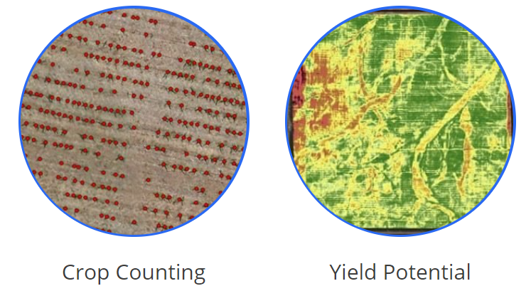

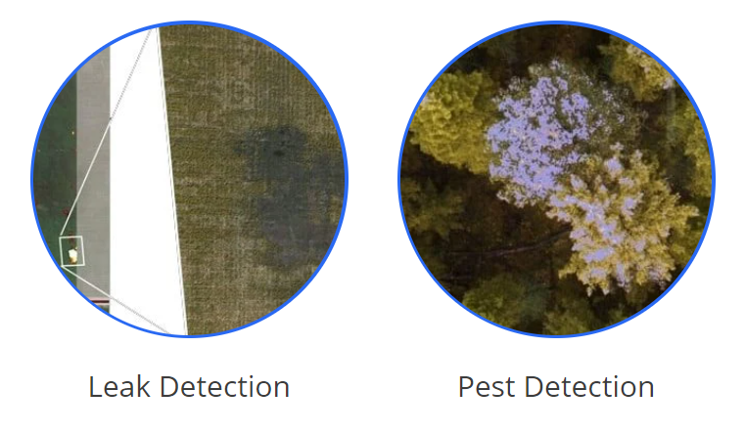

**Sensors**

* Still image cameras
* Video
* Multispectral  
  - Identify nutrient deficiencies, pest damage, fertilizer needs and water quality.
* Hyperspectral  
  - Used to analyze plant nutrients, plant diseases, water quality, and mineral and surface chemical composition.
* Lidar  
  - Using lasers this  sensor produces elevation data that can create 3D models of your farm
* Thermal  
  - Track the surface temperature of land and plants

In combination these sensors can give a 3D GPS accurate model of your field

and data that the human eye can not pickup on much less track easily over time.

Some terms you might hear are: Normalized Difference Vegetation Index

(NDVI) and Normalized Difference Red Edge (NDRE). NDVI is basically a

measure of plant health based on how a plant reflects light at specific

frequencies. Healthy plants reflect large amounts of near-infrared light (NIR)

where unhealthy plants absorb more.

**CHAPTER 11**

**RESULTS**

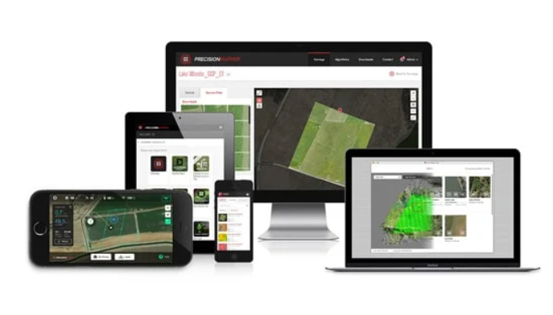

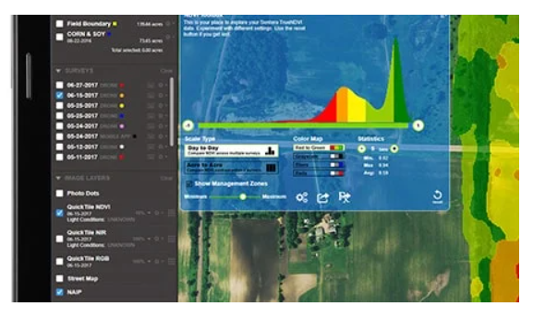

Drone software will first off let you map your field and create flight paths. Once you have flown your route you then need the software to help determine what is actually going on in your field over time, what actions to take and send that data along to your team and equipment on the ground.

**CHAPTER 12**

**CONCLUSION**

Drones or UAVs will be of immense help in the field of agriculture with the increase in population as they are essential at the very beginning of a crop cycle. It will not only reduce time but also yield better cultivation based on analyzed data. Crop management will be more efficient due to systematic monitoring. With the upcoming technologies, the production rate will increase rapidly with lesser consumption of energy. The major advantage of Drone is the auto landing capability which reduces the risk factors designed in a simple and cost effective manner. The study investigated the importance of drones in agriculture and is regarded as an eye-opener in industry and agriculture for development and integration of more drones for making agriculture tasks better in near future.

**CHAPTER 13**

**FUTURE SCOPE**

New applications are coming into picture as the work efficiency and tolerance capacity of the drones have surpassed all expectations. Recently India has also joined the picture by releasing its own drones. We can use our drone attached with camera for servieliance of MIT Campus. Developments and modifications are constantly being done on the structure and internal electronics. The new “helicopter drone” released by the US army carries a 1.8 giga pixel camera to provide clear ground images even from high altitudes. The sensors carried in the drones are also being made sharper to provide higher aerial surveillance. Programming software of the drone is being developed such that the drone can take its own decision in situations where human error is probable. Drones have always risen to the occasion whenever they were needed. They are truly an engineering spectacle, containing the best of mechanical, electronics and software technology.

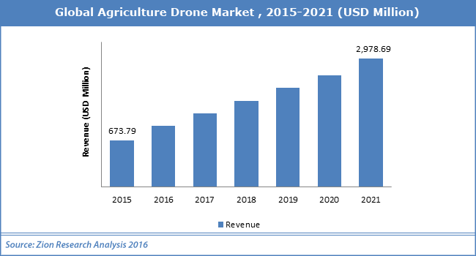

**CHAPTER 14**

**REFERENCES**

[1].Deepak Murugan, “Development of an Adaptive Approach for Precision Agriculture Monitoring with Drone and Satellite Data.” IEEE Journal of Selected Topics in Applied Earth Observations and Remote Sensing. (Volume:10,Issue:12,Dec 2017)

[2]. D. Yallappa, "Development and evaluation of dronemounted sprayer for pesticide applications to crops.", IEEE Global Humanitarian Technology Conference (GHTC),(Volume:133, Issue:16, 2017) [3]. Delle fav,Aero viroment’s global observer,Flying high,again,April 06,2011,Accessed October 27,2012 from defence industry. (Volume:121, Issue:54)

[4]. D. Anthony, et.al , On crop height estimation with UAVs. IEEE/RSJ Int. Conference on Intelligent Robots and System, 2014- .(Volume:23, Issue:11)

[5]. F.G. Costa and et.al”-, The use of unmanned aerial vehicles and wireless sensor network in agriculture applications. IEEE Int. Geoscience and Remote Sensing Symposium, 2012.(Volume:111,Issue:55)

[6]. Floriano De Rango, “A simulator for UAVs management in agriculture domain.”, International Symposium on Performance Evaluation of Computer and Telecommunication Systems (SPECTS), 2017(Volume:21, Issue:9)

[7]. Himadri Nath Saha, Abhilasha Mandal, Abhirup Sinha, “Recent trends in the Internet of Things”, IEEE 7th Annual Computing and CommunicationWorkshop and Conference (CCWC), 2017(Volume:33, Issue:32)

[8]. J. Primicerio et al -, A flexible unmanned aerial vehicle for precision agriculture. Precision Agriculture 13(4), 517-523, 2012(Volume:115, Issue:7)

[9]. Lei Shi, Qiguo Duan, Xinming Ma, Mei Weng,”The Research of Support Vector Machine in Agricultural Data Classification”,International Conference on Computer and Computing Technologies in Agriculture, CCTA 2011: Computer and Computing Technologies in Agriculture V pp 265- 269.(Volume:76,Issue:43)

[10]. Marthinus Reinecke, “The influence of drone monitoring on crop health and harvest size.” 1st International Conference on Next Generation Computing Applications (Next Comp), 2017. (Volume: 75, Issue:6)

[11]. Paolo Tripicchio, “Towards Smart Farming and Sustainable Agriculture with Drones.”, International Conference on Intelligent Environments (IE), 2015.(Volume:44, Issue:81)

[12]. Petterson,“Recent trends in the Internet of Things”, IEEE 7th Annual Computing and Communication Workshop and Conference (CCWC), 2017(Volume:412, Issue:77)

[13]. Rodrigo Filev Maia,“Precision agriculture using remote monitoring systems in Brazil.”, IEEE Global Humanitarian Technology Conference (GHTC), 2017. (Volume:36, Issue:79)

[14]. Theerapat Pobkrut, Tanthip Eamsa-ard, eerakiat Kerdcharoen, “Sensor Drone for Aerial Odor Mapping for Agriculture and Security Services”.(Volume:87, Issue:16)

[15]. Xie,”The Research of Support Vector Machine in Agricultural Data Classification”, International Conference on Computer and Computing Technologies in Agriculture, Computer and Computing Technologies in Agriculture.(Volume:24, Issue:41).